**TPx President’s Club 2018**

**Four Seasons Shanghai**

**May 5-9, 2019**

**Members of the 2018 Presidents Club will enjoy the following:**

As a TPx President's Club winner, you and your guest will be hosted on your choice of (1) of the preferred activities listed below on either Tuesday or Wednesday, May 7-8, 2019. Please select your top two choices per guest, to ensure you get the activity of your choice.  
*Additional activities can be requested in the activities section of the registration page of which you will be responsible for costs related. **Please note tours on both days, could be combined into one day group, to meet minimums required!!**

**All Experiences include:**

* **Personal English speaking guides**
* **All entrance fees**
* **Private roundtrip ground transportation**
* **Lunch if noted on description**
* **Gratuities for all guides and drivers**

**Tuesday May 7th, 2019 or Wednesday May 8th, 2019**

**These tours are currently offered both days!!**

**SHANGHAI ICONIC SITES**

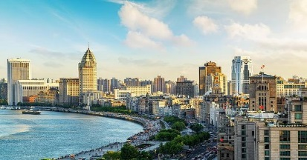 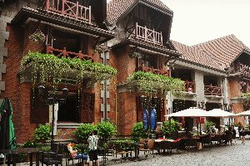 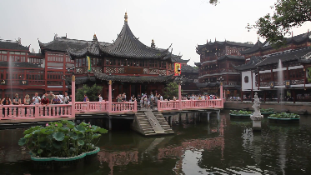

This tour gives a first time visitor the taste of both historic and modern Shanghai. Upon arrival to **Lujiazui’s** Financial Zone, the most glamorous place in Shanghai, you will see the **Oriental Pearl TV Tower**, the International Conference Center, Jin Mao Tower, World Financial Center and other futuristic Avant-garde buildings along with tall skyscrapers in this Pudong District.  Enjoy the exquisite gardens of **Yuyuan** with its unique design known where it’ beauty can be observed in tiny detailed carvings and structures. Feel relaxed as you wander through the corridors and archways, stop to marvel at the famed Exquisite Jade Rock and gaze upon the Great Rockery made of thousands of tons of stones.

Take a stroll thru the charming streets of **Tianziang**, where the contrast between colonial grandeur, contemporary style, and everyday Chinese lifestyles makes the Former French Concession so eclectic. As you continue thru the maze of small walkways dotted with quaint cafes, sumptuous restaurants and lively bars you will gain knowledge of its rich colonial history as it still retains an air of the “Paris of the East”. A visit isn’t complete without a stroll thru the **Shanghai Bund**, which has dozens of historical buildings, lining the river that once housed banks and consulates learning much about Shanghai’s history. **Lite local lunch arranged**.

**Where:** Meet in the hotel lobby 15 minutes prior to departure **What to bring:** Wear comfortable walking and layered clothing with a light jacket

**Activity time:**6 hours

**Hours:** 8:30 am–2:00 pm

**Minimum:** 15 guests

**Maximum**: 22 guests

**OFF BEAT & UNIQUELY SHANGHAI SITES**

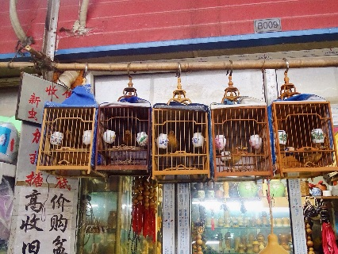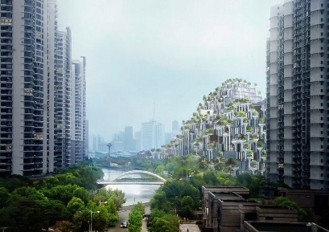

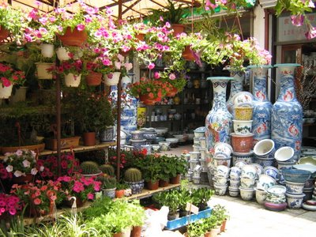

Visit the Xizang Nan **Flower and Bird Market** with a variety of rare birds, insects, and small animals along with colorful flowers. It consists of about a city block with rows of stall and vendors, each with a unique offering. At **50 Morganshan** Road, this particular art district was introduced by local artist Xue Song who initially was attracted to the extremely low rent for unused industrial space. About 25 percent today of the former factories have now been converted into fabulous art galleries, design center and studios. Walk thru and marvel at the odd little **Propaganda Poster Art Museum** which in 1995 began its history as a mere hobby for Mr. Yang Pei Ming. With spring in the air, let your eyes behold the beauty of and variety of the **Cherry Blossoms** which cover and area of 4.3 million sq meters in Gucun Park. There are at least 12,000 blossoms covering 82 species, it will simply take your breath away. **Lite local Lunch will be provided**.

**Where:** Meet in the hotel lobby 15 minutes prior to departure **What to bring:** Wear comfortable walking and layered clothing with a light jacket

**Activity time:**6 hours

**Hours:** 9:00 am – 3:00pm

**Minimum:** 15 guests

**Maximum**: 22 guests

**SHANGHAI SHOPPER’S DELIGHT**

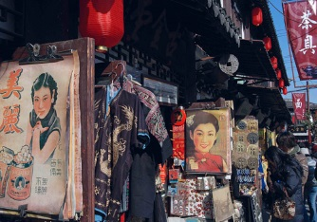 

At the **Xin Yang Market** you will encounter an array of tiny shops where one will find the **copy branded** souvenirs of top designer -like items and bargain prices. Next stop is **Shi Liu Pu Cloth Market** which houses a large variety of tailors and seamstresses. At this market which is one of the more manageable which offers a wide range of clothing accessories, buttons, zippers and trims. On to the **Tian Hou Silk Factory** where you will get a lesson on the process of the ancient Chinese silk industry starting from the silk worms to the completed works. Perhaps observe a local artist creating on the scene. Purchase some art pieces from landscapes to intricate classic Asian patterns in their gallery. Last but not least, if time allows a stop on **East Nanjing Road** which is the mecca for both shopping and people watching. This is the world’s busiest retail streets made for pedestrians only to brose and shop with several hundred stores containing brands from all over the world as well as international food and many restaurants. **You are on own for lunch at any of the great little outlets in this area.**

**Where:** Meet in the hotel lobby 15 minutes prior to departure **What to bring:** Wear comfortable walking and layered clothing with a light jacket

**Activity time:**6 hours

**Hours:** 9:15 am – 2:30pm

**Minimum:** 15 guests

**Maximum**: 22 guests

**ZHUJIAJIAO ANCIENT WATER TOWN**

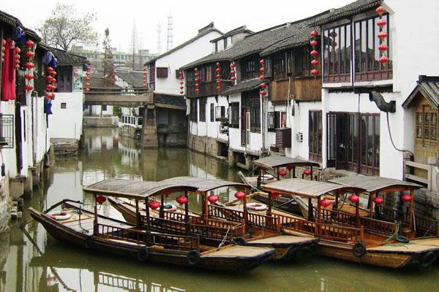

Make your own way to beautiful **Zhujiajiao Ancient Town**, a classic water village in the suburbs of Shanghai. It was built on the bank of Dianshan Lake and at the foot of Dianshan Hill within a beautiful scenic area. The village boasts 36 stone bridges and numerous rivers, with many ancient buildings lining the riverbanks.

Walk along on the Promenade Waterfront where you will enjoy 100-year old architecture and enjoy exciting views across the Huangpu River and riverside parks. This specific area was controlled by the British during the concessions period. Take a **gondola ride** the perfect way to experience how the local residents travelled for hundreds of years and gain insight into the method in which goods and people of this little town made it very prosperous. **A lite local lunch will be provided along the way!**

**Where:** Meet in the hotel lobby 15 minutes prior to departure **What to bring:** Wear comfortable walking/ layered clothing with a light jacket

**Activity time:**6 hours

**Hours:** 8:30 am – 2:30pm

**Minimum:** 15 guests

**Maximum**: 22 guests

**SPA QIN FOUR SEASONS SHANGHAI**

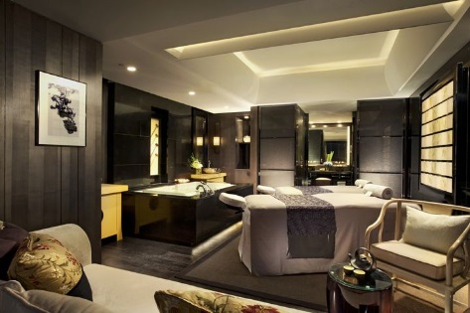 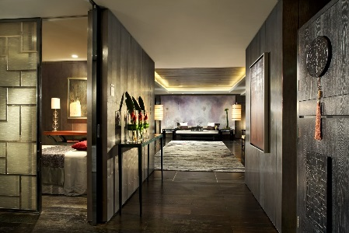

The atmospheric Qin Spa is a real highlight, an urban sanctuary of complete rejuvenation in a sleek and stylish setting on the 5th floor of the hotel. **Qin**, which is pronounced “chin” means to “affect deeply” offers an extensive range of massages, scrubs, wraps and facials are available but with the mini Forbidden City setting - lashings of black lacquer, circular doorways, grey sandstone and flickering candlelight – you should really opt for one of the deep-reaching Traditional Chinese Medicine therapies. **Appointment times** will be requested and confirmed back to you. We will provide a contact name and number at the spa should you wish to enhance or modify the experience further before arriving. On your arrival day the spa will also provide a confirmation of your reserved appointment day and time with services they are providing.

**Hosted Services with Gratuity included:**

**Imperial Dragon Massage/60 minutes**:We use poultices to prepare your muscles for the detoxifying massage movements that help to release deep-seated tension and tiredness.

**Aromatherapy Massage/60 minutes:**It is essential, professional and specific massage, using a blend of individually chosen oils inclusive of personal consultation that will ensure you receive a unique treatment to suit your specific needs.

**Traditional Tui Na Massage/60 minutes:** Tui Na is the traditional form of Chinese specialized massage that works only on areas of concern. Our trained specialists will do a consultation with you to ascertain what areas to work on in relieving pain and tension. The treatment is ideal for those with injuries, recurring problems or pain relief.

**Skin Purifying Facial/60 minutes:** Ideal for oily, congested and problematic skin or those suffering with hormonal imbalance. Deep cleansing facial helps to regulate and refine. Essential cleansing mask with Kaolin Clay and Benzoin to encourage a more balanced skin.

**Where:** Four Seasons Shanghai   
**What to wear:** Comfortable relaxed clothing

**Activity time:** Arrive at least 15 minutes prior to your scheduled treatment time

A **credit of $150.00** will be applied to the hotel’s spa appointment reserved. Additional costs, products, services or gratuities, will be billed to your room incidental account